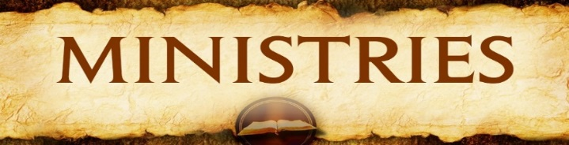

St. Mary’s May 2024 Ministry Schedule

Sunday, May 5, 2024 – 9 am
(6th Sunday of Easter)
Lector- Ron Polman
Eucharistic Minister – Dean Onken
Altar Servers – Gavin Manning
Greeters – Dan Hoffman & Mike Horner
Money Counters –Dan & Donna Hoffman
Music – Chris & Amanda Sieling

Sunday, May 12, 2024 – 9 am
(7th Sunday of Easter/Ascension/Baccalaureate/Mother’s Day)
Lector- Seniors
Eucharistic Minister – Mike Horner
Altar Servers – Anna & Thane Matthys
Greeters – Seniors
Money Counters – Bruce & Karen Gustafson
Music – Trent & Christie Gergen

Sunday, May 19, 2024 – 9 am
(Pentecost Sunday)
Lector- Greg Goepferich
Eucharistic Minister – Ron Polman
Altar Servers – Caden Brunsvold
Greeters – Paul Neisius & Neil Kroger
Money Counters – Julie Neisius & Ron Nelson
Music – Lynn Nelson, Christina Hagen & Lydia Weverka

Sunday, May 26, 2024 – 9 am
(Most Holy Trinity)
Lector- Mary Beth Sinclair
Eucharistic Minister – Ron Polman
Altar Servers – Hudson Weverka
Greeters – Brenda Streich & Matt Weverka
Money Counters – Matt & Lucinda Weverka
Music – Chris & Amanda Sieling

Sunday, June 2, 2024 – 9 am
(The Most Holy Body and Blood of Christ/Corpus Christi)
Lector- Jane Weidauer
Eucharistic Minister – Mary Beth Sinclair
Altar Servers – Gavin Manning
Greeters – Bernie Heck & Barry Weidauer
Money Counters – Jerold & Catherine Drager
Music – Trent & Christie Gergen

